**INFOLABZ IT SERVICES PVT. LTD.**

**Course :** React

**Session No :**

**Topics to be covered :** Custom Components ( External Js Files )

**Note:** In this project we will not create components in app.js but we will create components in other file ( custom file created by developers, for example we will create a new file in src folder lets say name of file is customcomp.js ).

( Use same folder every time while creating a new project. D:\reactprojects\ )

Create a new project : customcomponents

Command : npm init react-app customcomponents

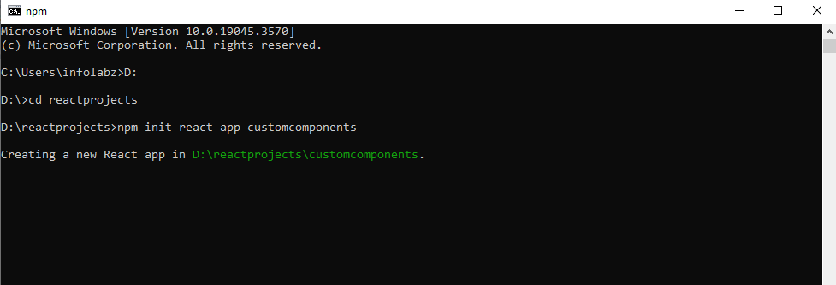

Load project folder in Visual Studio Code ( VsCode )

App.js file :

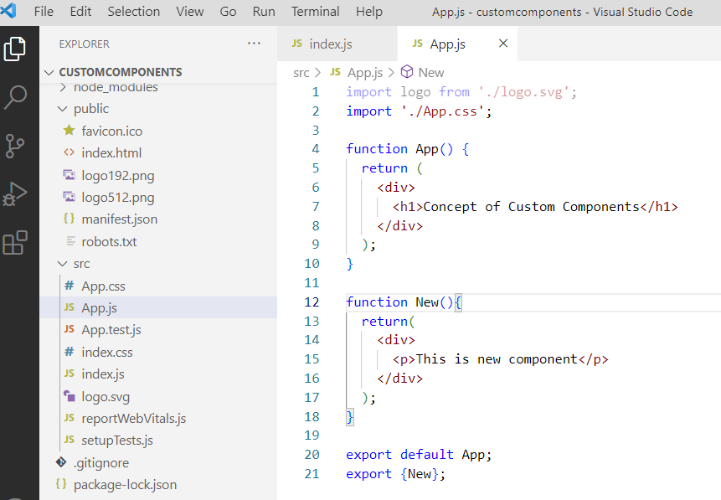

Index.js file :

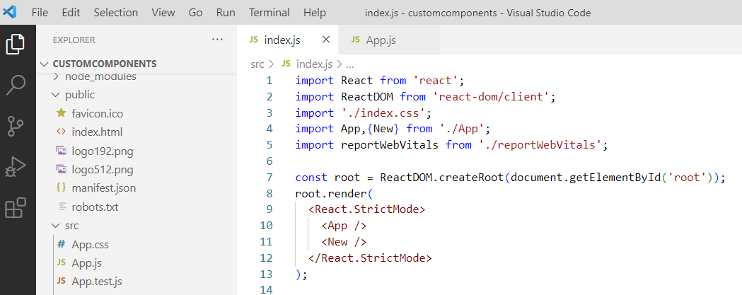

Output :

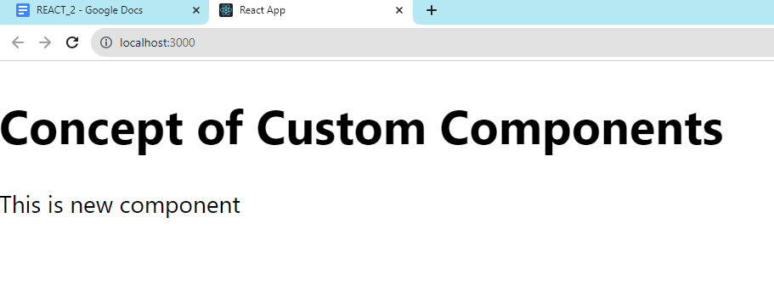

Create New file : customcomps.js inside source folder

( right click on src folder > New file > write customcomps.js )

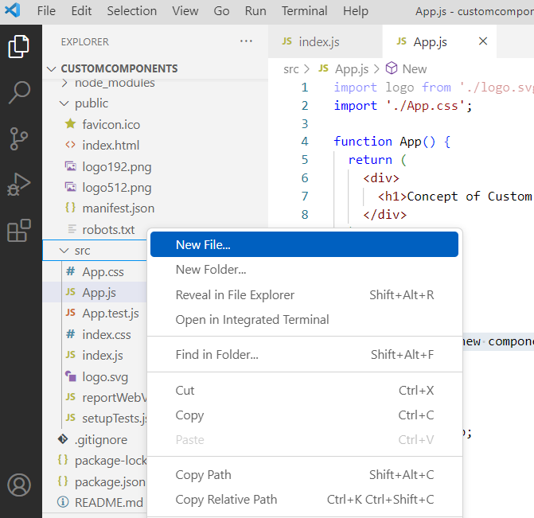 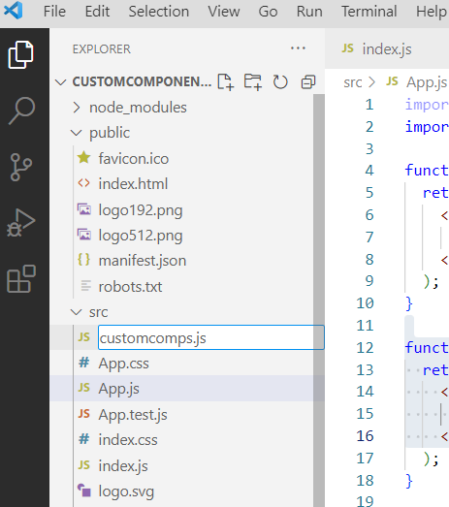

**CONCEPT 1 : Create First component export to index.js**

customcomps.js

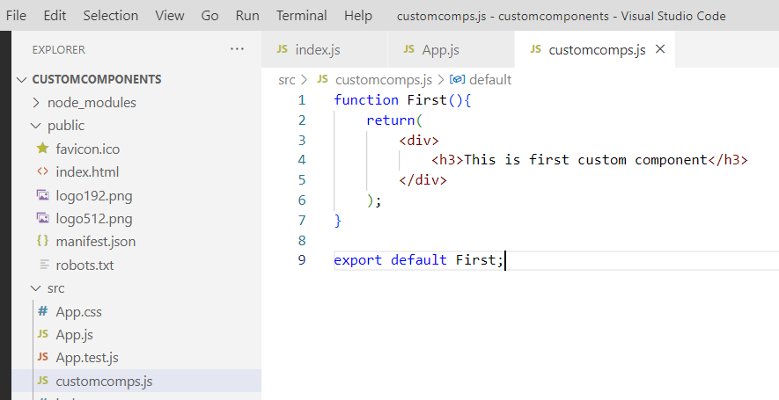

Index.js

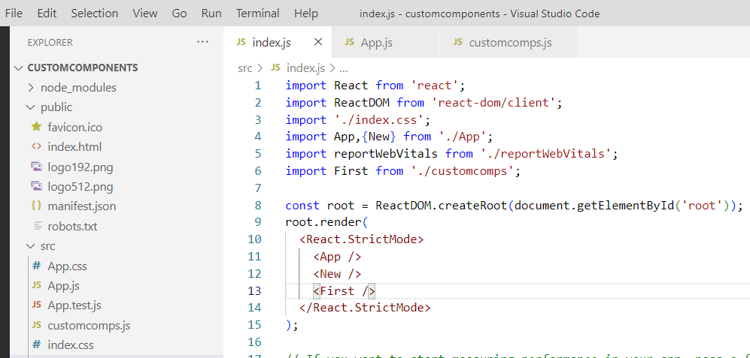

Output :

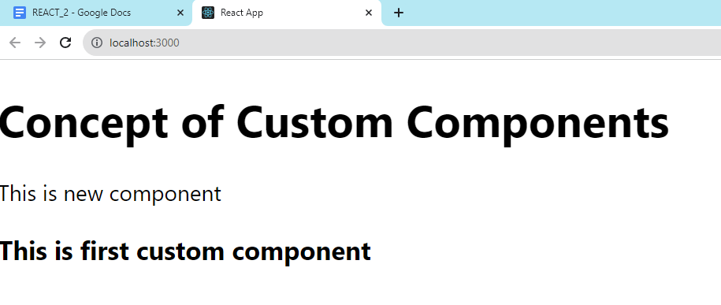

**CONCEPT 2 : Create Second & Third components export to app.js ( Use it in App and New components respectively )**

Customcomps.js

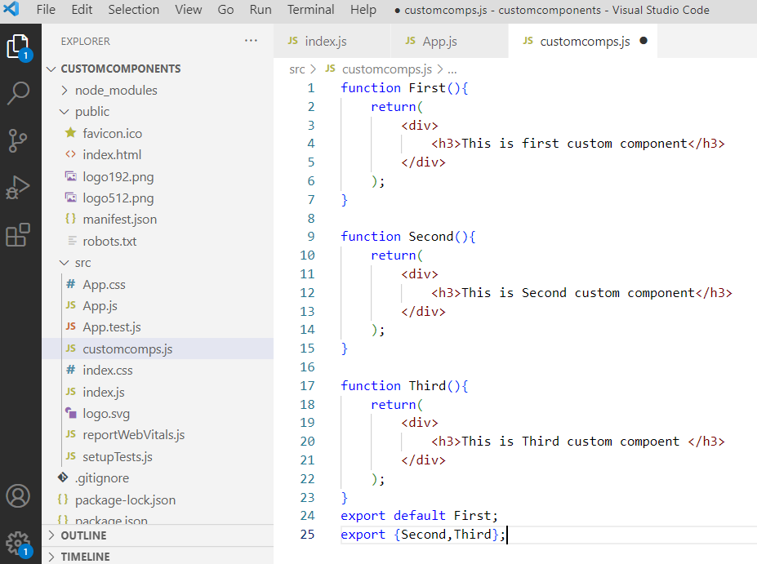

App.js

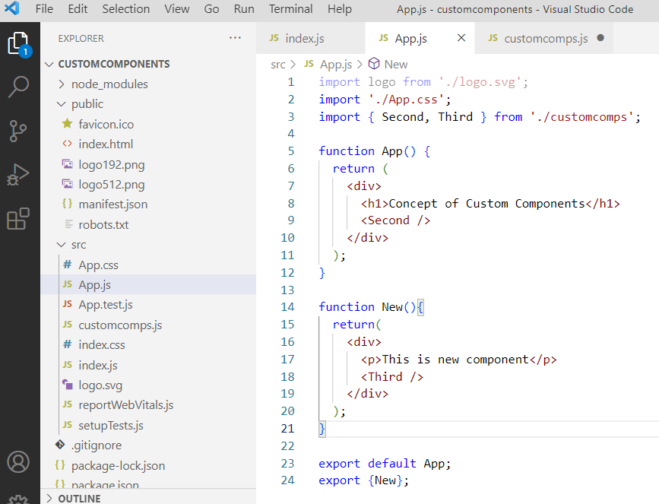

Output :

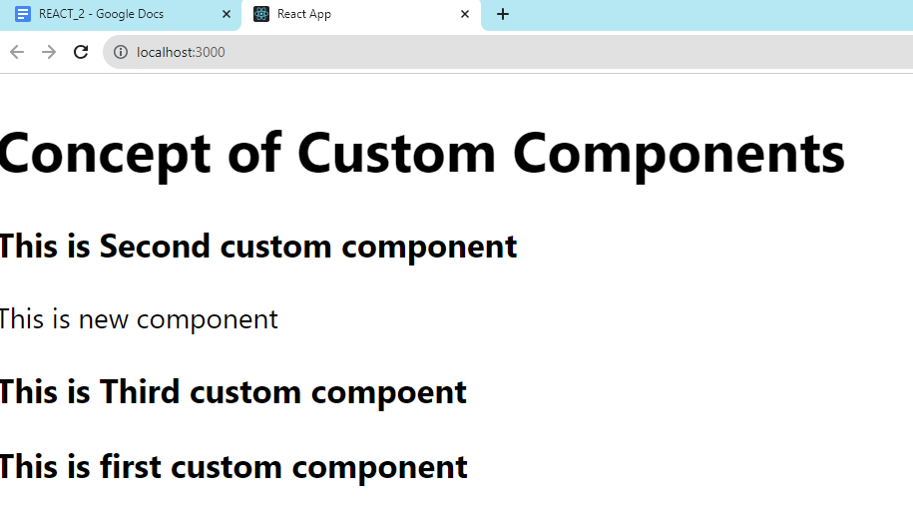

Observe above output : Why first component printed in last ?

**CONCEPT 3 : Using components without exporting it.**

Customcomps.js

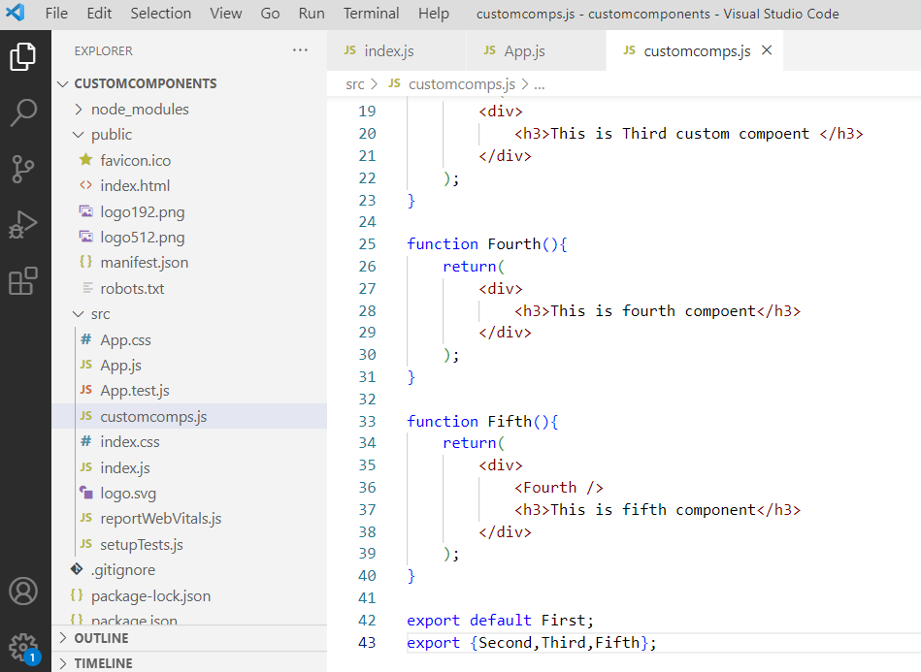

Note that we have not exported Fourth component but used it in Fifth component.

Index.js

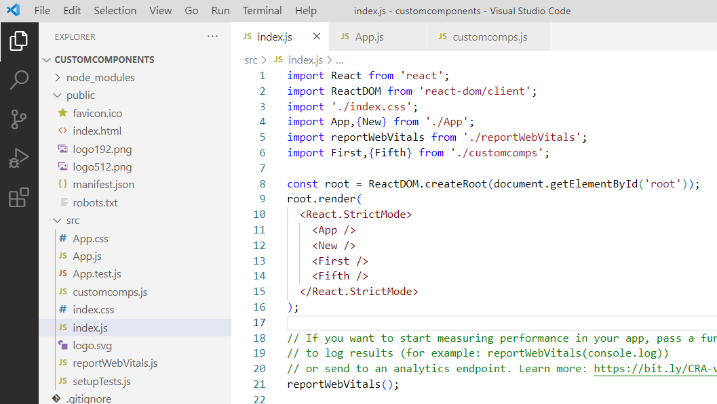

Output:

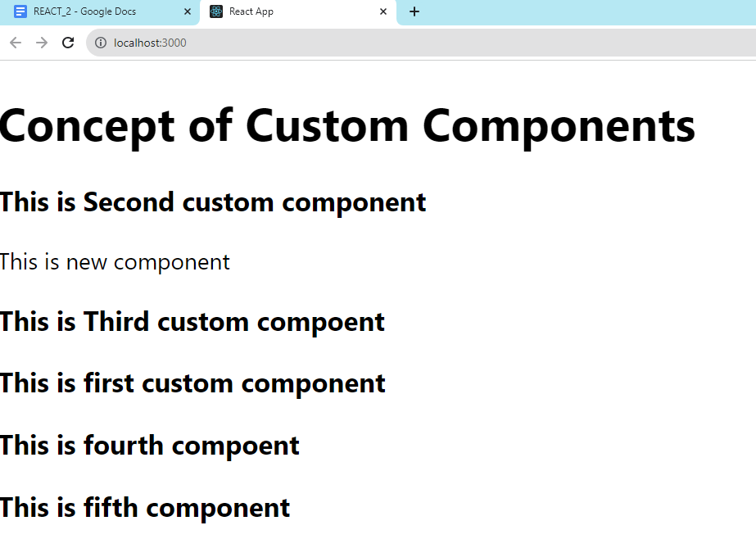

**Structured Representation :**

| **App.js** | App [ Second ] (DE), New [ Third ] (E), **Next (E)** |
| --- | --- |
| **Customcomps.js** | First (DE), Second (E), Third (E), Fourth(XE), Fifth [Fourth,**Next**] (E) |

**NESTING OF COMPONENTS**

When one component used in / with other component is concept of nesting of components.

| **Create New react project : componentpractice** | |
| --- | --- |
| **App.js** | App (DE), First (XE), Second [ First, Login ](E) , Third [Fourth,Logout] (E) , Fourth (XE), Buttons [Login,Logout,Addtocart] (E) |
| **Customcomps.js** | Login (DE), Logout (E), Addtocart (E), All (E) [Login, Logout, Addtocart] |
| DE: export default , E : Export, XE : Not Export | |